 **Mahavir Education Trust's**

Shah & Anchor Kutchhi Engineering College,

**Chembur, Mumbai 400 088**

UG Program in Information Technology

|  |  |  |  |  |  |
| --- | --- | --- | --- | --- | --- |
| **Experiment No. 03** | | | | | |
| **Date of Performance:** |  | | | | |
| **Date of Submission:** |  | | | | |
| **Program formation/ Execution/**  **ethical practices (07)** | **Documentation (02)** | **Timely Submission (03)** | **Viva Answer (03)** | **Experiment Marks (15)** | **Teacher Signature with date** |
|  |  |  |  |  |  |

**NAME: KRISHA SAYLA**

**ROLL.NO: 70**

**CLASS: TE-6**

**Experiment No: 3**

**Aim:** To Perform various GIT operations on local and Remote repositories using GIT Cheat-Sheet.

**Lab Outcome:**  To obtain complete knowledge of the “version control system” to effectively track changes augmented with Git and GitHub

**Theory:**

# Git Cheat Sheet

### 1. Git configuration

* **Git config**  
  Get and set configuration variables that control all facets of how Git looks and operates.  
  **Set the name:**  
  $ git config --global user.name "User name"  
  **Set the email:**  
  $ git config --global user.email "Krisha.sayla@gmail.com"  
  **Set the default editor:**  
  $ git config --global core.editor Vim  
  **Check the setting:**  
  $ git config -list
* **Git alias**  
  **Set up an alias** for each command:  
  $ git config --global alias.co checkout  
  $ git config --global alias.br branch  
  $ git config --global alias.ci commit  
  $ git config --global alias.st status

### 2. Starting a project

* **Git init**  
  **Create a local repository:**  
  $ git init
* **Git clone**  
  **Make a local copy** of the server repository.  
  $ git clone

### 3. Local changes

* **Git add**  
  **Add a file** to staging (Index) area:  
  $ git add Filename  
  **Add all files** of a repo to staging (Index) area:  
  $ git add*
* **Git commit**  
  **Record** or snapshots the file permanently in the version history **with a message**.  
  $ git commit -m " Commit Message"

### 4. Track changes

* **Git diff**  
  Track the changes that have not been staged:

$ git diff  
Track the changes that have staged but not committed:  
$ git diff --staged  
Track the changes after committing a file:  
$ git diff HEAD  
Track the changes between two commits:  
$ git diff Git Diff Branches:  
$ git diff < branch 2>

* **Git status**  
  Display the state of the working directory and the staging area.  
  $ git status
* **Git show Shows objects:**  
  $ git show

### 5. Commit History

* **Git log**  
  Display the most recent commits and the status of the head:  
  $ git log  
  Display the output as one commit per line:  
  $ git log -oneline  
  Displays the files that have been modified:  
  $ git log -stat  
  Display the modified files with location:  
  $ git log -p
* **Git blame**  
  Display the modification on each line of a file:  
  $ git blame <file name>

### 6. Ignoring files

* **.gitignore**  
  Specify intentionally untracked files that Git should ignore. Create .gitignore:  
  $ touch .gitignore List the ignored files:  
  $ git ls-files -i --exclude-standard

### 7. Branching

* **Git branch Create branch:**  
  $ git branch List Branch:  
  $ git branch --list Delete a Branch:  
  $ git branch -d Delete a remote Branch:  
  $ git push origin -delete Rename Branch:  
  $ git branch -m
* **Git checkout**  
  Switch between branches in a repository.  
  Switch to a particular branch:  
  $ git checkout  
  Create a new branch and switch to it:  
  $ git checkout -b Checkout a Remote branch:  
  $ git checkout
* **Git stash**  
  Switch branches without committing the current branch. Stash current work:  
  $ git stash  
  Saving stashes with a message:  
  $ git stash save ""  
  Check the stored stashes:  
  $ git stash list  
  Re-apply the changes that you just stashed:  
  $ git stash apply  
  Track the stashes and their changes:  
  $ git stash show  
  Re-apply the previous commits:  
  $ git stash pop  
  Delete a most recent stash from the queue:  
  $ git stash drop  
  Delete all the available stashes at once:  
  $ git stash clear  
  Stash work on a separate branch:  
  $ git stash branch
* **Git cherry pic**  
  Apply the changes introduced by some existing commit:  
  $ git cherry-pick

### 8. Merging

* **Git merge**  
  Merge the branches:  
  $ git merge  
  Merge the specified commit to currently active branch:  
  $ git merge
* **Git rebase**  
  Apply a sequence of commits from distinct branches into a final commit.  
  $ git rebase  
  Continue the rebasing process:  
  $ git rebase -continue Abort the rebasing process:  
  $ git rebase --skip
* **Git interactive rebase**  
  Allow various operations like edit, rewrite, reorder, and more on existing commits.  
  $ git rebase -i

### 9. Remote

* **Git remote**  
  Check the configuration of the remote server:  
  $ git remote -v  
  Add a remote for the repository:  
  $ git remote add Fetch the data from the remote server:  
  $ git fetch  
  Remove a remote connection from the repository:  
  $ git remote rm  
  Rename remote server:  
  $ git remote rename  
  Show additional information about a particular remote:  
  $ git remote show  
  Change remote:  
  $ git remote set-url
* **Git origin master**  
  Push data to the remote server:  
  $ git push origin master Pull data from remote server:  
  $ git pull origin master

### 10. Pushing Updates

* **Git push**  
  Transfer the commits from your local repository to a remote server. Push data to the remote server:  
  $ git push origin master Force push data:  
  $ git push -f  
  Delete a remote branch by push command:  
  $ git push origin -delete edited

### 11. Pulling updates

* **Git pull**  
  Pull the data from the server:  
  $ git pull origin master  
  Pull a remote branch:  
  $ git pull
* **Git fetch**  
  Download branches and tags from one or more repositories. Fetch the remote repository:  
  $ git fetch< repository Url> Fetch a specific branch:  
  $ git fetch  
  Fetch all the branches simultaneously:  
  $ git fetch -all  
  Synchronize the local repository:  
  $ git fetch origin

### 12. Undo changes

* **Git revert**  
  Undo the changes:  
  $ git revert  
  Revert a particular commit:  
  $ git revert
* **Git reset**  
  Reset the changes:  
  $ git reset -hard  
  $ git reset -soft:  
  $ git reset --mixed

### 13. Removing files

* **Git rm**  
  Remove the files from the working tree and from the index:  
  $ git rm <file Name>  
  Remove files from the Git But keep the files in your local repository:  
  $ git rm –cached

**OUTPUT:**

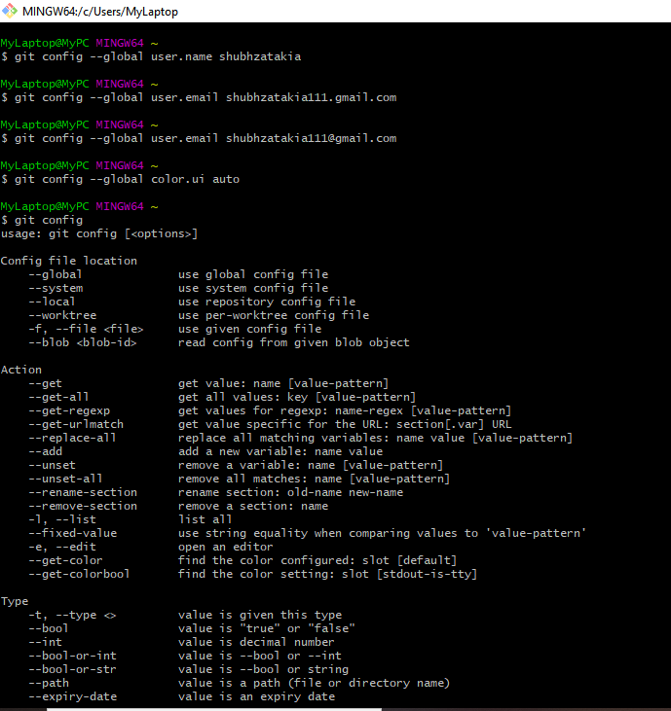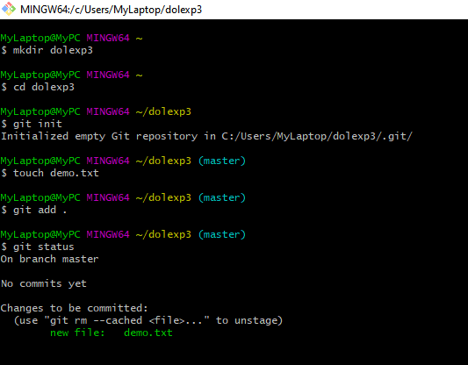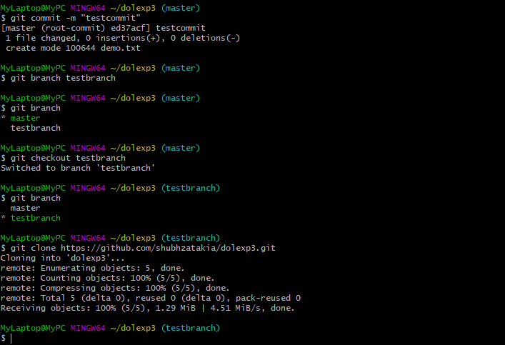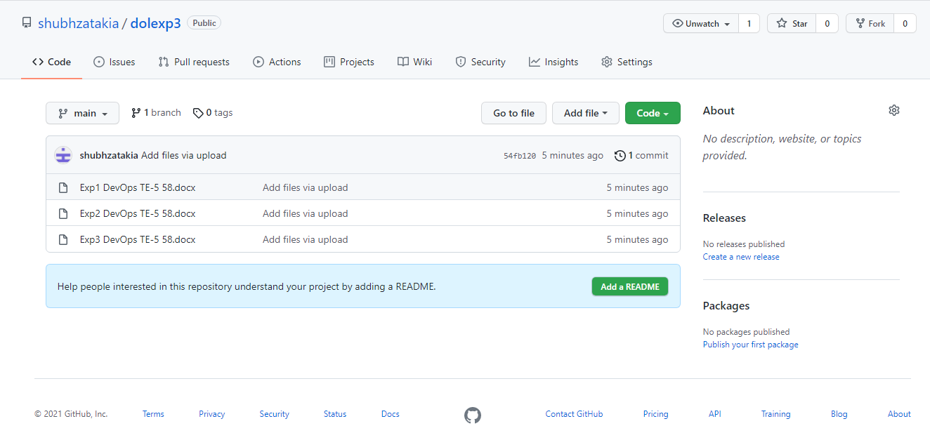

**Conclusion:**

Hence, I have learned and executed various git commands to perform task like creating directory, uploading data to directory, fetching data from directory etc.